1. INTRODUCTION

1.1 OVERVIEW

Radisson owns multiple five-star hotels across India. They have been in the hospitality industry for the past 100 years. Due to strategic moves from other competitors and ineffective decision-making in management, Radisson is losing its market share and revenue in the luxury/business hotels category.

1.2 PURPOSE

The primary purpose of hotels is to provide travelers with shelter, food, refreshment, and similar services and goods, offering on a commercial basis things that are customarily furnished within households but unavailable to people on a journey away from home.

2. PROBLEM DEFINITION AND DESIGN THINKING

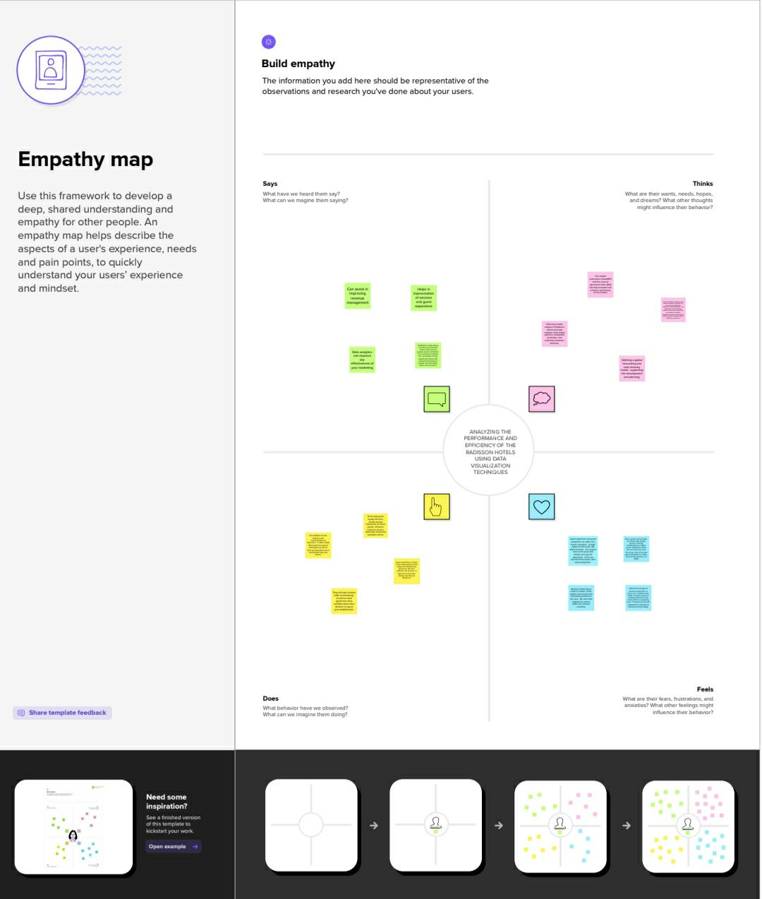 2.1 IDEATION AND BRAINSTORMING MAP

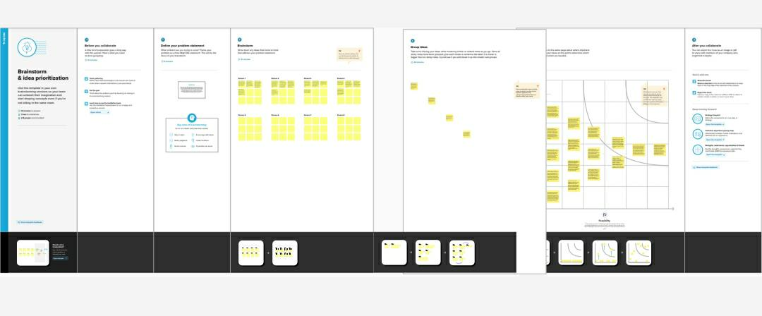3. RESULT

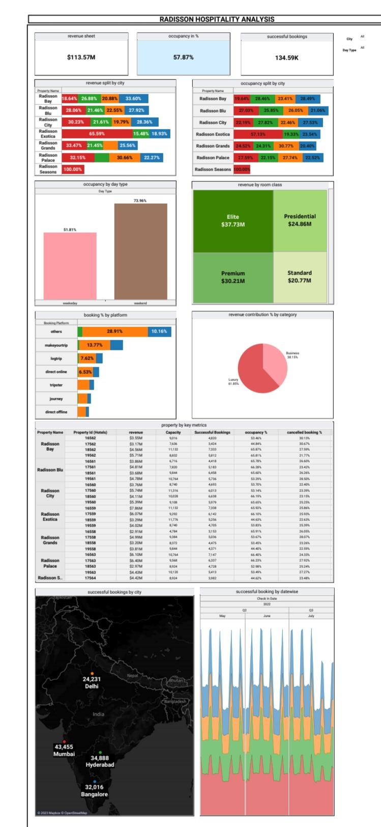

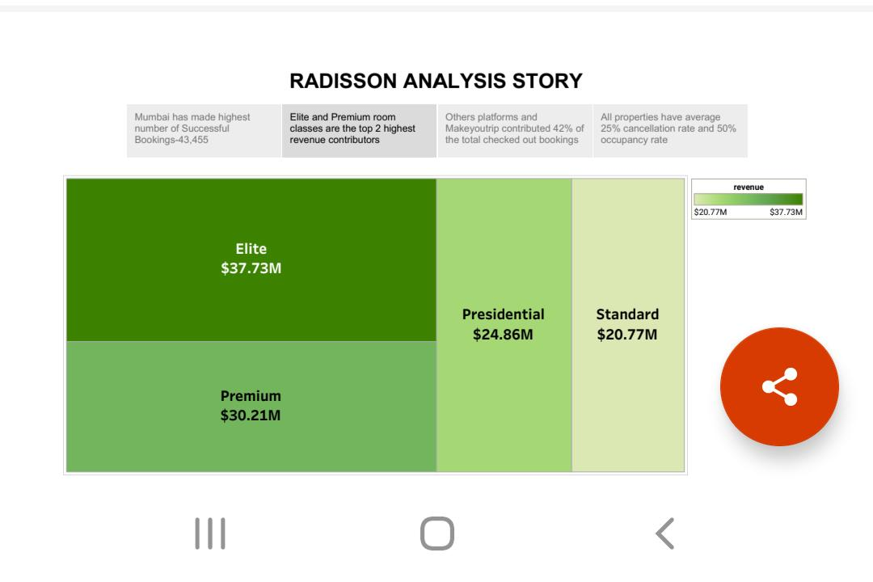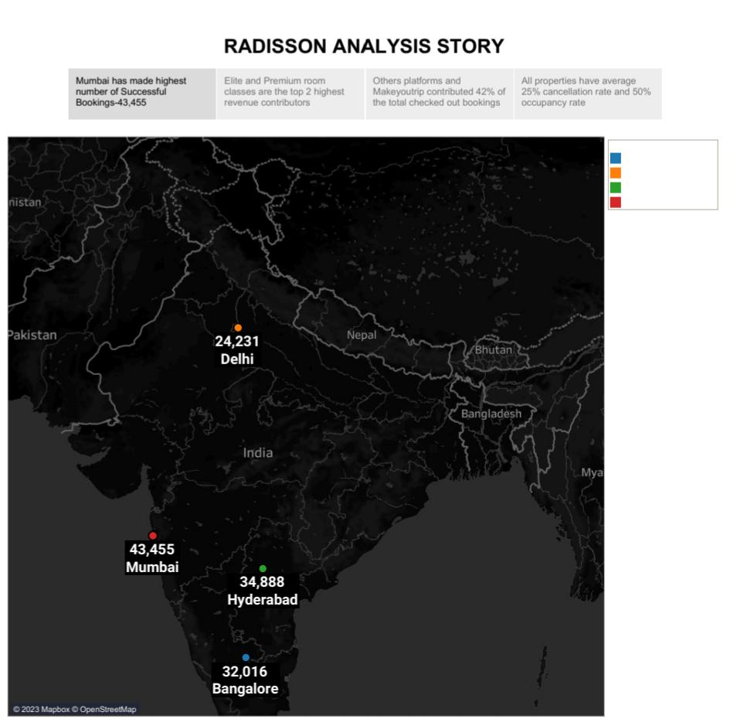

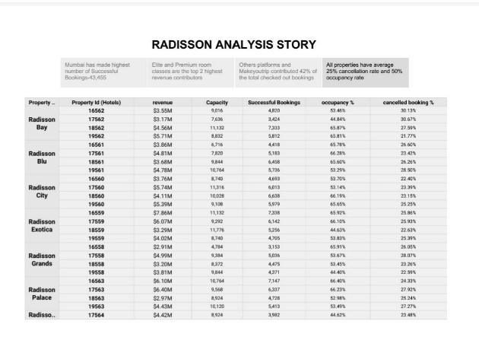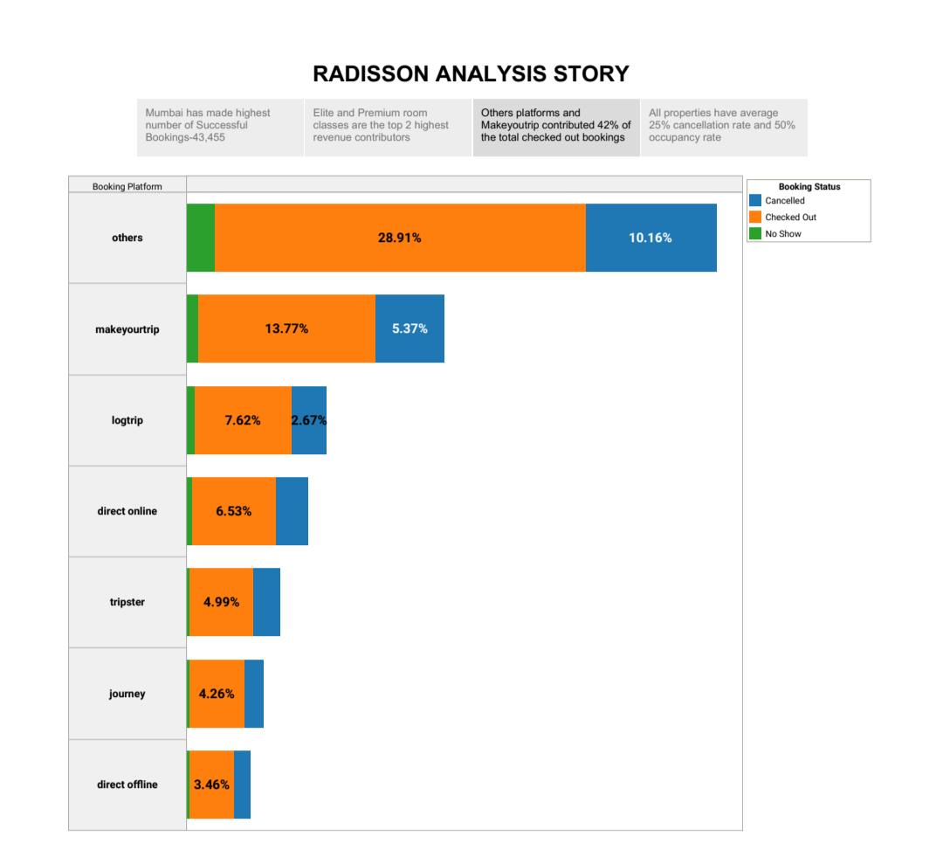4. ADVANTAGES AND DISADVANTAGES

ADVANTAGES

1. With us, you can book a reservation in advance or walk up to the hotel to find a room

2. Our hotel has comfortable beds and bedding to ensure a good night’s sleep24-hour reception and room service are just a phone call away

DISADVANTAGE

1. Because hotels, especially chains, are virtually the same around the world, you may be giving up a cultural experience.

2. Hotels can be more expensive than other forms of accommodations as well.

5. APPLICATIONS

Guests can use your hotel app to read your recommendations on things to do, get directions, discover services you offer, peruse your restaurant menu, book a table or spa treatments and much more.

6. CONCLUSION

The hotel feasibility study requires analysis and expertise beyond other types of commercial real estate. A hotel or resort feasibility study requires a thorough market analysis involving a study of the economic and demographic factors as well as a review of the hotel market.

7. FUTURE SCOPE

The hospitality industry is highly competitive, so it's important that it moves with the times. Additionally, customer expectations are always shifting based on new technologies that are introduced. Obsolete systems will have a negative impact on your bottom line

8. APPENDIX

An appendix comes at the end (after the reference list) of a report, research project, or dissertation and contains any additional information such as raw data or interview transcripts. The information in the appendices is relevant but is too long or too detailed to include in the main body of your work.

9. HTML

